INNER TEMPLE LIBRARY
NEWSLETTER

Tel: 020 7797 8217/8218 Fax: 020 7797 8224
Email: library@innertemple.org.uk
Website: www.innertemplelibrary.org.uk
Catalogue: www.innertemplelibrary.org/external.html

Issue 28 April 2012

Welcome to the Inner Temple Library’s quarterly electronic newsletter. The newsletter aims to keep members and tenants of the Inner Temple up to date with news and developments in the Library.

All feedback is welcome and can be sent to librarynewsletter@innertemple.org.uk

Annual Review

The Library's Annual Review for 2011 is now on the website. Click here to view.

New Justis Databases

The Library now has access to three new Justis databases - England and Wales Judgments Court of Appeal (Criminal Division) 1963-1989, British Virgin Islands Cases and Jamaican Cases.

Opening Hours

We intend to operate our normal summer vacation hours (9.00 a.m. to 5.30 p.m.) during the Olympic Games, 27 July to 12 August. However, since Library staff (and everyone else) are likely to experience problems with travelling into central London by public transport during this period, we hope that our users will bear with us if we need to change these hours at short notice.

Saturday Opening

One of the four Inn Libraries is open from 10.00 a.m. to 5.00 p.m. on each Saturday during the legal terms.

April
28 April Inner Temple

May
5 May* Middle Temple
12 May* Lincoln's Inn
19 May Gray's Inn
26 May Inner Temple

June
2 June CLOSED
9 June Lincoln's Inn
16 June Middle Temple
23 June Gray's Inn
30 June Inner Temple

July
7 July Lincoln's Inn
14 July Middle Temple
21 July Gray's Inn
28 July CLOSED

* Please note change in order

To view a Saturday Opening Timetable up to December 2012 click here.

New to Pupillage?

If you are starting pupillage and have not used the Inner Temple Library before, you may be interested to know what the Library can do to help you.

Enquiry Point Staff

Our experienced Library staff are able to assist with a wide range of legal research problems. From finding commencement dates and deciphering abbreviations to tracing the judicial history of a case, we can help. If you do not know how to find a book or law report or if you need advice on where to start your research, visit the Enquiry Point and we will do our best to help.

Tours

If you have half an hour to spare and you would like to book a tour of the Library, please contact the Enquiry Desk and make an appointment. This is a good way to find out more about the collections and services on offer.

Databases

We have a full range of legal databases available for use in the Library. There are guides (specially written by Library staff) to help you use them effectively and you can ask staff for advice on searching. If you need refresher training on a database or need assistance because a database is new to you, contact tdennis@innertemple.org.uk to make an appointment. We will do our best to fit in with your timetable.

FAQs

On our website there is a series of legal research FAQs which cover UK and EU case law and legislation, treaties and parliamentary publications. They offer suggestions on hard copy and online resources that can be used to answer specific types of questions.

AccessToLaw

AccessToLaw is a gateway site providing annotated links to authoritative free legal websites in the UK, Europe and worldwide. The content is selected and updated by Library staff. If you cannot come into the Library to do your research, AccessToLaw is a good place to start.

Current Awareness Blog

This blog will help you to keep up to date with developments in the legal world. The daily posts, which are selected and updated by Library staff, cover legal news, new case law, changes in legislation and government press releases. You can sign up to receive daily updates by email, subscribe to the RSS feed or follow the blog on Twitter.

Document Supply Service

We operate a document supply service for barristers who cannot come into the Library in person. This is a charged-for service. Documents can be emailed, faxed or posted. Details of the service and the charges involved can be found on the Library website.

Refresher Training in Legal Research

If you feel that you need some refresher training, contact tdennis@innertemple.org.uk. We will try to accommodate your training needs.

The Library has many services that can make research easier. The staff are on hand to help and assist. It is to your advantage to make use of this excellent resource.

Current Awareness Anniversary

The Current Awareness blog was launched five years ago in April 2007. Since then it has been updated on a daily basis by Library staff and provides users with the latest in legal news, case law and legislation.



- Over 20 sources are checked on a daily basis, and 47 sources are monitored in total

- Sources now include selected chambers websites

- The blog has a searchable archive of over 23,000 posts

- All posts are indexed using a controlled vocabulary: there are now over 1,000 categories

- There are 20,000 visits per month, from over 100 countries, and over 4,000 subscribers

Users' comments

"Current Awareness is the simplest and most reliable way for lawyers to keep up to date with what is going on in the legal world. The Inner Temple Library team never miss an important event or article."
- Adam Wagner, UK Human Rights Blog
(www.ukhumanrightsblog.com)

"An extremely useful digest of latest resolutions and legal news stories from around the web, updated regularly." - The Times

"It really is an excellent facility, and I already find it invaluable. It is particularly useful when I am out of chambers, in the UK or abroad, as it provides not only information but also all the hot-links I need."
- Nigel Pleming QC

"So many sources, so little time…THE leading resource for keeping lawyers on top of the legal news, commentary and authorities, Current Awareness from the expert Inner Temple librarians, is indispensible."
- Emily Allbon, LawBore / City Law School
(http://lawbore.net/)

"It is easy to miss legal news on a crowded net. The Inner Temple Library's Current Awareness team don't…. a first class news and awareness service. Essential."
- Charon QC, blogger
(http://charonqc.wordpress.com/)

Legal Research FAQs: Researching Parliamentary Publications

Library staff have recently produced a guide which aims to answer frequently asked legal research questions on Parliamentary publications. We hope this will be useful to students, pupils and barristers.

The guide is available on the Library's website. Click here to view.

It consists of a series of questions and answers relating to Parliamentary publications. The answers feature both electronic and hard copy sources.

Questions covered include:

"How do I find details of House of Commons and House of Lords Papers?"

"How do I find information on the progress of Bills?"

"How do I find the text of Debates?"

"How do I find Standing Committee/Public Bill Debates?"

The guide does not aim to provide an exhaustive listing of sources but rather to include sources which Enquiry Point staff have found most useful, and which are to be found in the Inns of Court Libraries. The electronic sources mentioned include free websites and subscription-based databases.

This is the fourth set of FAQ guides that the Inner Temple Library has produced. The other sets cover UK legislation and case law, EU legislation and case law, and Treaty research. We hope to expand the series and cover other aspects of legal research.

If you have any comments about this guide or suggestions for future guides, please contact tdennis@innertemple.org.uk.

Bloody Tales of the Tower

Three royal letters from the Library's manuscript collection are shortly to appear in a new television series on the Tower of London, Bloody Tales of the Tower, which is presented by the Tudor historian, Dr Suzannah Lipscomb, and Joe Crowley. The manuscripts will be featured in the second episode of the series, Executions, which will be screened on the National Geographic Channel on Monday 23 April at 8p.m.

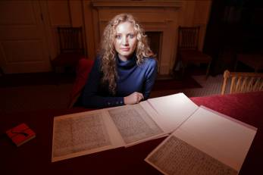

Dr Suzannah Lipscomb viewing royal letters

Visitors

Recent visitors to the Library have included a group of East European lawyers, interns from ENSSIB (France's national school for information and librarianship) and graduate trainees working in the library of the law firm, Hogan Lovells.

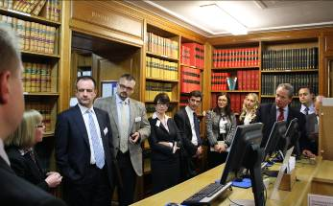

The Deputy Librarian welcomes visiting East European lawyers, 21 March

A Visit to LSE Library

Mark Leonard, Library Assistant, writes

Having a central London location brings the Inner Temple Library close to many other wonderful libraries, and this affords valuable and interesting collaborative opportunities. We are always keen to receive visits from the staff of other libraries, to discuss our methods and practices, and we are equally keen to make visits to other libraries ourselves. It was in this spirit that last month we received a visit from an LSE Library intern, and that my colleague Roia McHugh and I made the reciprocal, short journey across Fleet Street to the LSE Library.
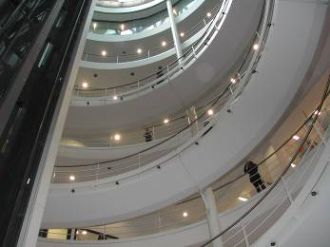

LSE Library
interior

The Library, designed by Norman Foster and opened in 2001, is an open, light and inviting space, extending over seven floors around a spectacular central spiral staircase. The staircase leads the eye up to a glass-domed roof, which supplies the whole Library with natural light, complementing the white-walled interior perfectly. The lower ground floor is occupied largely by a combination of computers and beanbags, so we were presented with the (to us) incongruous scene of students sleeping and relaxing along one wall and slightly more alert students typing away along the other. This adds to the relaxed feel of the Library, as do the light airiness of the space and the freedom that students enjoy to eat, drink and sleep within the Library itself. Especially studious members, or at least those with pressing and stressing deadlines, could almost live there given the 24-hour opening policy.

We were given a comprehensive tour by two librarians, Mei Pang and Emma Buckley, who explained the design of the Library and the organisation of Library services, pointing out that reference/research, IT and photocopying queries are respectively channelled to three separate enquiry points. Vonny Bee, the Teaching Support Manager, then gave us an in-depth and interesting talk about the academic services and student support that her team offers; this made us appreciate just how much work is involved in providing a service for so many users.

Maria Bell, the Academic Support Librarian for Law, gave us a further insight into this, but with a special focus on the law department. What particularly struck us were how the same materials we have in our Library were used differently at LSE because of their different readership, and the amount of research teaching and online advice that they provide for the students. We certainly appreciated our morning at the LSE, and will be buying a beanbag very soon.



Mark Leonard and Roia McHugh, Inner Temple Library Assistants (and beanbag)

William Petyt and the Petyt Manuscripts

Adrian Blunt writes

Many previous issues of the Newsletter have contained references to the Library's collection of manuscripts. One of the best known items in the collection, perhaps the single item most frequently mentioned, is King Edward VI's 1553 "devise for the succession". This belongs to the largest of the collection's five groups, the Petyt Manuscripts, and its citation is Petyt MS 538, vol.47 fo.317. But who was Petyt? How did the Library come to hold his manuscript collection? And what else is to be found amongst its 386 volumes?
William Petyt (1637-1707) was a member of the Inner Temple. He was a native of Yorkshire, from the village of Storiths close by the ruins of Bolton Priory near Skipton. He practised at the bar, was a writer particularly on the history and functions of Parliament, was in due course elected a Master of the Bench of the Inner Temple, and served as Treasurer in 1701-02. His legal career began, however, not in the Inner Temple but in the Middle Temple, where he was called to the bar in 1660. He was specially admitted by the Inner Temple in 1664, and thereafter clearly regarded himself primarily as an Inner Templar. Though not much is known about his legal practice, he appears to have been successful at the bar.

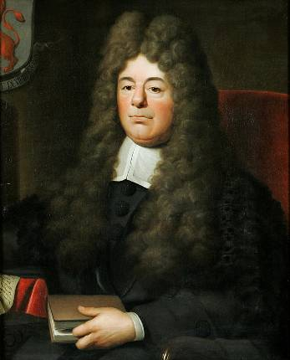

William Petyt in around 1700, by an anonymous English painter

Petyt's five published works include Miscellanea Parliamentaria (1680), Lex Parliamentaria (1690) and the posthumously published Jus Parliamentarium (1739). He was a devoted parliamentarian, and it was following the success of the parliamentarian cause in the Great Revolution of 1689 that he was appointed Keeper of Records in the Tower of London. The bulk of his manuscript collection was probably assembled during the seventeen years that he held that office.

Petyt died in 1707. In his will he named six trustees who, in respect of his manuscripts and books, were to "use their utmost endeavours for preserving and keeping them safe and entire". In addition he left £150 "to buy or build a place ... for preserving and keeping them ...." The Library was duly extended to accommodate them, making it possible for the trustees to direct before the end of 1708 that the collection "shall forever hereafter be deposited and kept in the late erected Library of the Inner Temple". In the new Library the manuscripts occupied most of the book presses numbered 502 to 538, and they have been cited ever since according to those original press numbers. The manuscript volumes in the bequest totalled fewer than 300, but somehow, mostly in the ensuing forty or fifty years, a number of volumes from a variety of other sources came to be associated with the Petyt press numbers, making a total of 386 volumes.

Almost half of the manuscripts in the Petyt bequest group are transcripts of public records, many, not surprisingly, from the Tower of London, but from a variety of other sources too, including the Rolls Chapel, the Chapter House of Westminster Abbey, Westminster Hall, the Palace of Westminster and from many private collections. To the layman these transcripts may seem less interesting than the original manuscripts in the collection, but their historical importance is considerable. Their range is wide, including Assize Rolls and other judicial records, Chancery records, Exchequer records and various parliamentary and ecclesiastical records. The parliamentary records are particularly extensive. The first Petyt press number (502), for example, is a long series of 83 volumes containing transcripts of the Journals of the House of Commons from 1604-1624 and 1660 to 1708. Some of the original documents from which Petyt made his transcripts no longer exist. Others have deteriorated since Petyt's day to the point where they are now unusable. In such instances the Petyt transcripts provide the only existing versions or the most accurate versions now available.

Most of the remaining items in the collection are original documents. One small group of volumes comprises medieval chronicles and other popular European works of the medieval period. They include an early fifteenth-century Polychronicon of Ralph Higden, a fourteenth-century Speculum Historiale of Vincent de Beauvais, and an illuminated Historia Anglorum of Roger de Hoveden which once belonged to the Abbey of Rievaulx and which was probably written in the Durham scriptorium about 1220. Another in this group, a manuscript of Macrobius's commentary on Cicero's Somnium Scipionis, beautifully written and illuminated probably in the mid twelfth century, is thought to be the oldest manuscript in the Library.

Amongst the many legal items are some early collections and abridgments of statutes, including one printed by Machlinia and Lettou c.1481 and others printed by Machlinia c.1484 and 1485. Many other items reflect Petyt's special interest in Parliament, for example three separate drafts of Henry Elsynge's Modus tenendi Parliamentum, one of which is annotated by the jurist and scholar John Selden.

For many the most interesting volumes are those containing holograph letters and other documents mainly from the second half of the sixteenth century. Amongst them are letters by William Cecil (Lord Burghley), Sir Edward Coke and Sir Christopher Wren, and two letters bearing the signature of Queen Elizabeth I: the familiar, elaborately curlicued "Elizabeth R".

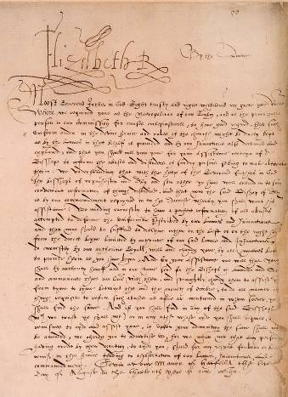

Letter from Elizabeth I to Archbishop Matthew Parker, 1571
Most fascinating of all is a group of documents relating to the royal succession crisis of 1553. The best known of these, alluded to earlier, is a draft made in June 1553 in which the dying King Edward VI, at the instigation of his protector John Dudley, Duke of Northumberland, sets out his "devise for the succession", excluding his sisters Mary and Elizabeth in favour of Northumberland's daughter-in-law Lady Jane Grey. The other documents from this period include a letter from Lady Mary, later Queen Mary (written by another but with additions in her own hand), to her brother Edward VI on 16 May 1553 expressing concern for his health; a letter dated 9 July 1553 in which Mary, under signet and sign manual "Marye the Quene", announces to Sir Edward Hastings the death of Edward three days earlier; and finally a letter dated 18 July 1553 in which Lady Jane Grey, under signet and sign manual "Jane the Quene", writes to two of her supporters, just a few hours before her arrest and the end of her nine day reign.

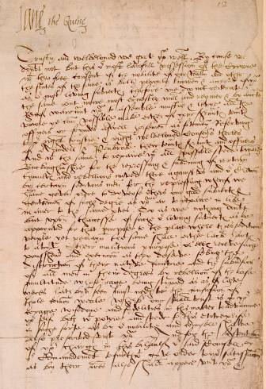

Letter from Lady Jane Grey as Queen, 18 July 1553

Of the 134 "Petyt" volumes which derive from sources other than the Petyt bequest, perhaps the most notable are the fourteen volumes of papers of Sir Martin Wright, who was a King's Bench judge from 1740 to 1755. There are papers on over a thousand cases heard by the judge during that period, together with precedents, proceedings and notes. These provide much detailed information on the law and legal procedure of the time. A portrait of Sir Martin Wright hangs near the Library entrance. Other items amongst these 134 volumes include Year Books for the period 10-17 Edward III (i.e. 1336-1344) and an illuminated manuscript of Walter Hilton's Scala Perfectionis dating from the first half of the fifteenth century.

Besides his books and manuscripts Petyt also left a further £50 to purchase additional books. In addition to the completion of the new building, the year 1708 saw the appointment of the Inn's first Librarian, Samuel Carter. By 1713 Carter had completed the first known catalogue, and in the same year there is the first record of an annual allocation (initially £20) being made for the purchase of books, at the discretion of the Treasurer and four other Masters of the Bench - in effect the first Library Committee. The Library's existence is first documented in 1505, but the Petyt bequest of 1707, with the direct and indirect consequences that followed over the next few years, was arguably the single most important development in its subsequent history.

Adrian Blunt retired as Deputy Librarian in 2006.

Focus on Lawtel

The Library's subscription to Lawtel includes several specialist areas. Among these are EU, Human Rights, Litigator, Employment, Local Government and Personal Injury. This article outlines the content of the EU, Human Rights and Litigator sectors. The other areas will be considered in a future issue.

EU

Key contents:

- Comprehensive coverage of all ECJ cases (except staff cases) since 1954, with links to the full text of the opinion or judgment and, from 1989, links to the text as published in the Official Journal C series

- All adopted legislation since 1987 and most legislation adopted prior to that date, from the foundation of the European Communities onwards. Details of UK implementation are given in the case of Directives.

- Proposed legislation since 1987 with details of the various stages of the legislative process

- The full text of the Treaty of Nice which came into force on 1 February 2003, as well as every Article of the EC Treaty and EU Treaty, both in the Maastricht version (from 1 November 1993) and the Amsterdam version (from 1 May 1999). Also included are Maastricht protocols, Amsterdam protocols and Declarations. Various accession treaties are reproduced in full text.

- Press releases from the Commission, the Council, the European Parliament and other EU institutions since 1987

- A list of legislation nicknames with links to the full text

Human Rights

Key contents:

- Full text of The European Convention on Human Rights as amended by Protocol II, which came into force on 1 November 1998

- European Court of Human Rights judgments delivered in English since 1960

- Full text of the UK Human Rights Act 1988, both as originally passed and as consolidated, and a table showing its amendment history

- Full text of Council of Europe and United Nations treaties relating to human rights

Litigator

Lawtel Litigator is a collection of guides to civil procedure, providing a "how to" approach to litigation processes.

Key contents:

- A total of 49 procedural guides, arranged by subject

- A selection of precedents

- Full text of the Civil Procedure Rules (with details of subsequent amendments), practice directions and pre-action protocols

- A selection of forms

- Various court guides (Chancery, Queen's Bench, Patents, etc.)

- Cause lists
AccessToLaw: Wales

When AccessToLaw first went online many years ago it did not have a section, as it now does, devoted specifically to Wales. Wales is steadily developing its own legal personality, but there is of course no separate Welsh jurisdiction, England and Wales having formed a single unified jurisdiction since the time of Henry VIII. But there has been a devolved Welsh Government since 1999, and devolution has led to the creation in recent years of several new Welsh institutions and bodies.

So the first entry to note is that for the Welsh Government itself, which was known before May 2011 as the Welsh Assembly Government. The areas for which it has devolved responsibility include the economy, health, education and local government, and much of the site content is arranged under broad topics such as health and social care, transport, etc. There is also a Legislation section which provides information on and links to legislation both draft and in force, including Assembly Acts and Measures and subordinate legislation.

The body which has had the power since May 2007 to enact primary legislation in Wales (initially in the form of "Measures", and since May 2011 as Acts) is the National Assembly for Wales. Its site includes records of proceedings, Standing Orders, guidance on the legislative process and a link to the Government of Wales Act 2006.

The official UK database of Welsh legislation is to be found at Legislation.gov.uk: Wales. Assembly Acts and Measures are reproduced as revised, with an additional option to select the original "as enacted" text. Wales Statutory Instruments are also available there, unrevised, 1999 onwards.

Another site featuring information on legislation is that of the Wales Office. This is the Whitehall department (successor to the pre-devolution Welsh Office) through which the UK Government liaises with the devolved Welsh Government, and its site includes information (with links to texts) on England and Wales legislation 2005/06 onwards which has specific provisions or implications for Wales.

The unified court system of England and Wales means there is no body of Welsh case law as such. There are however several tribunals which are administered separately in Wales and which have their own websites, such as the Special Educational Needs Tribunal for Wales and the Valuation Tribunal for Wales, all containing useful information and in some instances details of decisions. Education and local government are amongst the areas of policy devolved to the Welsh Government, as is health and social care. The remaining entries to be noted are for various regulators, ombudsmen and other bodies concerned with these areas, amongst them the

Care Council for Wales, the General Teaching Council for Wales and the Public Services Ombudsman for Wales.

In the light of developments over recent years the question has increasingly been raised in Wales as to whether a separate Welsh legal jurisdiction is now desirable or feasible. Only a few weeks ago, on 27 March, the Welsh Government opened a public consultation on the matter. The closing date for responses is 19 June 2012, and the consultation document may be viewed on the Welsh Government's website.

New Acquisitions

Many thanks are due to the following members of the Inn, and others, who have presented new titles or editions to the Library since the last newsletter: Master Reynolds (joint author) for Carver on bills of lading, 3rd edition; Christopher Loxton for International aspects of family law, 3rd ed. by Resolution (formerly Solicitors Family Law Association); Master Roger Stewart (joint editor) for Jackson & Powell on professional liability, 7th edition; Stephen Field for Prison law index 2011-2012; Martin Fodder (joint author) for Whistleblowing: law and practice, 2nd edition.
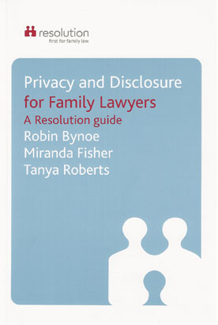
In Privacy and disclosure for family lawyers, (Resolution) Robin Bynoe, Miranda Roberts and Tanya Fisher look at how lawyers should approach the task of establishing whether a spouse has made a full and accurate disclosure of assets. The book investigates data protection, confidentiality and privacy, as well as the linked matter of the opening of the courts to the press and others, and the resetting of the balance between the right of the public to know how our courts work and the rights of the individuals involved to keep the details of their lives private.
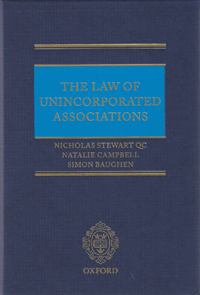

The Law of unincorporated associations by Nicholas Stewart QC, Natalie Campbell and Simon Baughen (OUP) begins by defining such an association, and explaining what distinguishes it from other forms of clubs. It goes on to provide guidance on practical matters such as rules, committees, meetings and registration of names, and discusses disciplinary action against members, liability in tort and in contract, and civil court procedure.

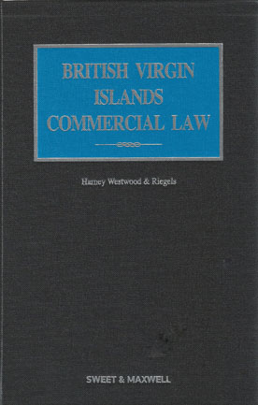
British Virgin Islands commercial law (Sweet & Maxwell) by the BVI law firm Harney Westwood & Riegels is an important addition to our Commonwealth textbooks collection in that it is the first and only legal practitioners’ work that focuses exclusively on the British Virgin Islands. It covers companies, credit and security, mutual funds, insolvency, dispute resolution, taxation, trusts and other areas.

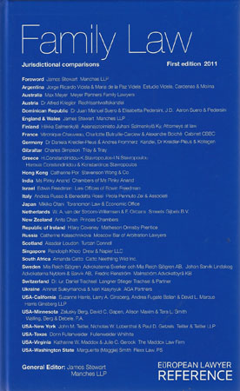
The contributors to Family law: jurisdictional comparisons (European Lawyer) are practitioner Fellows of the International Academy of Matrimonial Lawyers, and the book provides concise commentary on the law relating to pre- and post-nuptial agreements, divorce, children, cohabitation and same-sex relationships in Argentina, Australia, Austria, Dominican Republic, England & Wales, Finland, France, Germany, Gibraltar, Greece, Hong Kong, India, Israel, Italy, Japan, The Netherlands, New Zealand, Ireland, Russia, Scotland, Singapore, South Africa, Sweden, Switzerland, Ukraine, and in the USA: California, Minnesota, New York, Texas, Virginia and Washington State.

BIALL Quiz

Peter Higgins, Systems Librarian, writes

If Paul McCartney's middle name is Paul, what is his first name? What's the difference between Adobe and Adobe Acrobat? Is Elvis Costello the twin brother of Eric Morecambe and/or Nikola Tesla, and did any of them write Anne of Green Gables?

Yes, it's the 2012 BIALL quiz, and the pressure is on. BIALL? Well, for those who haven't encountered this euphonious acronym, it's the British and Irish Association of Law Librarians. Hosted by John Evans of Prenax, and sponsored by Prenax and Wildy & Sons, the quiz has become something of an institution. This year eighteen teams crammed themselves into the basement bar of the Penderel's Oak, High Holborn, to try to work out, among other things, the square root of 145,924.

After last year's success, we (the Inner Temple Library team) found ourselves at the same (lucky?) table and prepared to defend our title. Not entirely convinced we had any chance of achieving the double, I was nevertheless disappointed to hear, at the halfway mark, that we were not in first place. How had this happened? After all, we had worked out all the Cryptic Chocolate Clues (possible team-name for next year?) and won some very nice chocolates into the bargain. We had even deduced that wretched square root (382, if you are still wondering), through a combination of educated guessing and just guessing. But our limited knowledge of the game of draughts, and our lamentable decision not to listen to the only team member who knew how to spell Massachusetts, were to be our downfall.

Or so I thought. Suitably refreshed after the half-time feast we launched ourselves into part two with renewed enthusiasm. But the leaders, representing Hogan Lovells, maintained their impressive lead through the logo round (BT? BP? MSNBC?), the music round (one team member's knowledge of Level 42 came in handy here) and the entertainment round. Going into the home straight, we were still three points behind, with ten questions to go – the captain of the Titanic, the Birdman of Alcatraz, Paul "Paul" McCartney ... but was it too little, too late?

Time for the final scores. We'd already agreed on the drink we would use to drown our sorrows (Desperado, with a slice of lime stuck in), so imagine our surprise when the winners were announced. Yes, somehow we had triumphed after all. Our commiserations go to Hogan Lovells, and our thanks to the organisers for such a well-run and mind-boggling quiz. Apparently there is another scheduled for October. Can we make it three in a row?



Our team at the BIALL Quiz on 13 March

